**Symbiosis School, Nasik.**

**Std: X Term I (2020-21)**

**Subject: English Language & Literature - Worksheet – 40**

**Lesson : Chapter 10 – Sermon at Benares By Betty Renshaw**

**About the Author**

Betty Louise Renshaw Barber was born in Shannon, Mississippi on September 3, 1927, to P. C. and Lillian Renshaw. After graduating valedictorian from Shannon High School, she went on to obtain her Bachelor of Arts degree from Mississippi College, and later a Master of Arts from Mississippi University for Women. She taught at the preschool level for several years, and eventually, she was able to pass her experiences on to others by teaching preschool teachers. She also taught preschool education for a number of years at Mississippi College. 

**The Sermon at Benares- Introduction**

The Sermon at Benares throws light upon the early life of Lord Buddha who was originally born as a prince in the royal family. On being exposed to the sufferings of the world which he was earlier shielded from, he left his princehood and went in search of salvation thus leaving all the worldly pleasures behind. Upon attaining spiritual awakening, he gave his first sermon in the city of Benares hereby making a lady named Kisa Gotami realise that men are mortal and a wise person should not grieve at what is bound to happen for it only enhances pain and suffering.

### ****The Sermon at Benares- Summary****

Gautama Buddha was born to a North Indian royal family as a prince and was named Siddhartha Gautama. When he was twelve years old, he was sent to a far away place to study Hindu sacred scriptures and upon returning four years later, he got married to a princess. Soon, they both had a son and they continued to live the royal life for about ten years. The royals were shielded from all the unpleasant experiences of the world until one day, on his way to hunt, the Prince met a sick man, an aged man, a funeral procession and a monk begging for alms. These experiences acted as eye-openers for him and thus, he left all the royalty behind to seek a higher sense of spiritual knowledge. Upon attaining salvation, he began preaching. He gave his first sermon in the city of Benares. There was a lady named Kisa Gotami whose son had died. Suffering with unending pain, she went from house to house looking for a medicine to bring her son back to life. People started thinking that the lady had lost her senses. One day, she met a man who directed her towards Lord Buddha who could possibly have a solution for her problem. Buddha asked her to look for mustard seeds and the seeds must be procured from a house that had seen no death. Reinstated with hope, Kisa Gotami once again went on a search from house to house but to her dismay, she could not find mustard seeds from a house that would fulfill Buddha’s condition. Disheartened, she sat at the edge of the road thus realising how selfish she had been. She became conscious to the fact that men were mortal and no one could escape the cycle of life. This was exactly what Buddha wanted her to understand. According to Lord Buddha, feelings of grief and sorrow only increases man’s pain and suffering thus, deteriorating his health. Therefore, a wise person fully aware about nature’s functioning must not grieve at something bound to happen and only then he can be happy and blessed.

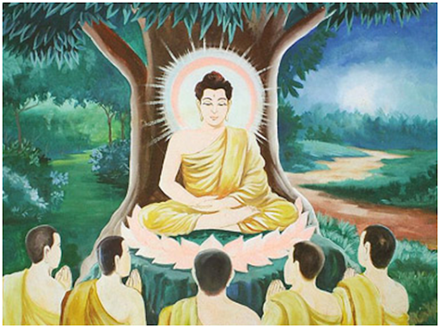 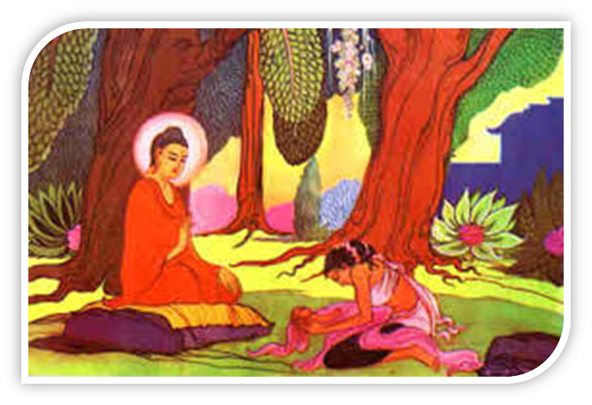

**Word Meanings**

Sacred- embodying the laws or doctrines of a religion  
Scriptures- the sacred writings of a religion  
Befitted- be appropriate for; suit  
Chanced upon- came across by chance  
Alms- money or food given to poor people; charity  
Enlightenment- a state of high spiritual knowledge

Wandered- to move without a fixed course  
Vowed- solemnly promise to do a specified thing  
Preached- deliver a religious address to an assembled group of people  
Sermon- a talk on religious or moral subject  
Holy- sacred  
Dipping places- bathing  
Inscrutable- something which cannot be understood

Kinsmen- a man who is one of a person’s blood relations  
Lamenting- express regret or disappointment about something  
Slaughter- killing of animals for food  
Afflicted- affect adversely

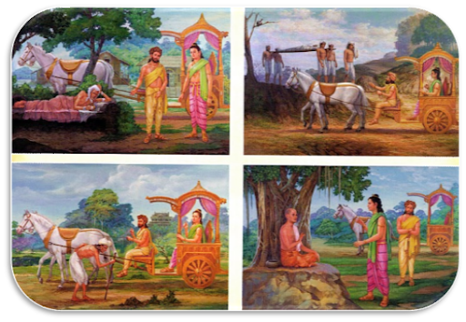

**Character Sketch of Kisa Gotami**

Kisa Gotami was the wife of a wealthy man of Savatthi. She had only one child. When her son was old enough to start running about, he caught a disease and died. Kisa Gotami was greatly saddened. Unable to accept that her son was dead and could not be brought back to [life](http://www.speakingtree.in/public/topics/life/life) again, she took him in her arms and went about asking for medicine to cure him. Everyone she encountered [thought](http://www.speakingtree.in/public/topics/thoughts/thought) that she had lost her [mind](http://www.speakingtree.in/public/topics/thoughts/mind). Finally, an old man told her that if there was anyone who could help her, it would be the [Buddha](http://www.speakingtree.in/public/topics/god/buddha).

In her distress, Kisa Gotami brought the [body](http://www.speakingtree.in/public/topics/health/body) of her son to the Buddha and asked him for a medicine that would bring back his life. The Buddha answered: "I shall cure him if you can bring me some white mustard seeds from a house where no one has died". Carrying her dead son, she went from door to door, asking at each house. At each house the reply was always that someone had died there. At last the truth struck her, "No house is free from death". She laid the body of her child in the wood and returned to the Buddha, who comforted her and preached to her the truth. She was awakened and entered the first stage of Arhatship. Eventually, she became an Arhat.

**Character Sketch of Buddha**

Prince Siddhartha was the only son of king Shuddhodana. The king loved him very much. He provided him all the luxuries of the palace. The astrologers had told the king that the Prince would be a great hermit. In the end he came to be known as Lord Buddha. We find in him the following qualities :

**1. A born thinker:** The Prince was not an ordinary man. He was very thoughtful from his childhood. He was born in a royal family. His life was full of luxuries and comforts. Yet he always thought about the life outside the palace. He wanted to see the realities of life. So he visited the city twice.

**2. Loving, merciful and sympathetic :** When the Prince saw an old man, a sick man and a dead body, he was very much grieved. He said, “The world suffers from fear. Love is short lived. Life ends into hateful death. So I shall do my best not to let anyone cry with pain.” When he saw the sick man crying for help, he lifted him up and comforted him. Thus he was loving, merciful and sympathetic.

**3. A good son and a good husband :** The Prince was a good son. He obeyed his father and always sought permission to go to the city. He was a loving and true husband also. He could never bear the tears in the eyes of his wife, Yashodhara.

**4. Curious for knowledge :** The Prince was very curious to get the knowledge of the world and its sufferings. He asked Channa many questions and got knowledge about different happenings.

**5. A super human :** The Prince had an extraordinary understanding. He got knowledge very soon. He sacrificed all his kingly pleasures and left home. He gave valuable advice to the people. So he became known by the name of Gautam Buddha.

**Concept Based Questions**

**1. Where did Buddha preach his first sermon?**

**2. What did Kisa Gotami learn in the end?**

**3. What did the Buddha preach to the people?**

**4. Describe the life of Gautama Buddha before enlightenment.**

**5. Which people are referred to as “wise” by the Buddha in his sermons?**